**Working Title: The Black Samurai.**

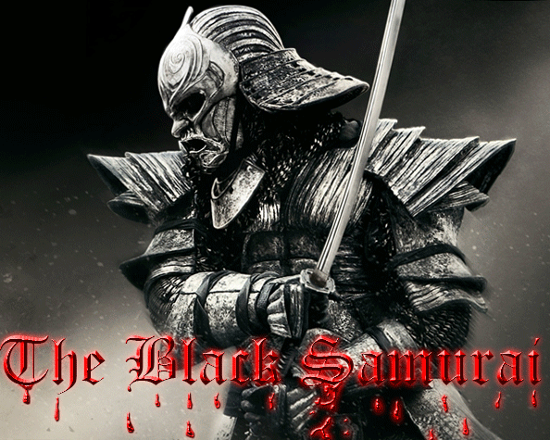

**Concept:**

Player controls a sword wielding samurai in a beat’m’up style side scrolling platform game in a fight to free Japan from the rule of a tyrant emperor. Gameplay will employ a unique control scheme and a levelling up system called honour. As the player progresses through the game the samurai regains more honour. More honour will increase the samurai’s power and speed. Backed by a compelling storyline and and gratifying game mechanics will make this game a joy to play without the need for achievements and collectables to hold the players interest.

**Storyline.**

You play as a once great and honourable Samurai whose loyalty now lies with the highest bidder. After the disbanding of his master’s house and the destruction of his home town this Ronin became bitter angry and selfish. Abandoning his moral code he started selling his sword skills to the powerful families in Japan to advance their political agendas. To reflect the darkness of his soul (and for stealth advantages) he reforged his armour with a matt black finish. And becomes known as the Black Samurai.

Unwittingly his actions lead him to witness the massacre of a small village. Feeling the urge to protect a family from Japanese Imperial Soldiers now puts him in the middle of moral conflict. He turns on his employers soldiers and saves the lives of a woman and a small child. Deeply bound once again by his honour he vows to serve this woman as he did his old master.

The woman sets him on a path to over through the emperor of Japan and free the people from this tyrant. Facing impossible odds and certain death the black samurai seeks to regain his honour and embarks on this suicide mission. Knowing that this is likely to be his last great fight he rebels openly against the emperor in the hopes his story will inspire other Ronin to band together to complete his mission.

**Control scheme.**

The controls for the samurai character will consist of 2 sets of X & Y axis controls. One for moving around and jumping and the other for swinging his sword in directions for attacks. Any contact of the sword on objects and enemies will cause damage to health depending on how the sword is swung with the 2nd direction controls. A calculation based on the number of changes in sword angle before contact, combined with the characters current speed will determine the amount of damage an attack makes. This is in line with the concept that fun is defined by pressing the boundaries of the limitations your presented with. This limited but unscripted control mechanic provides freedom for players to explore and develop their own fighting style.

**Genre and Inspirations for the game mechanics.**

Action/adventure platform/indie game. This game will specifically be classed as a side scrolling beat’em’up. Originally Inspired by Double Dragon 3 (Super Nintendo), it will involve the camera following the character through levels containing lots of enemies that the player must defeat with melee attacks. Double Dragon 3 was one of the 1st games of its kind to employ a more complicated fighting mechanics were players could grab, flip and thro enemies around using the same button. Variations of attacks were performed by timing your actions accordingly and combining with direction controls. Similarly timing attack coordination will be a major part of the fight mechanics but are not confined to scripted actions. Level design and physics inspired by Sonic the Hedgehog (Sega Master System), involving multiple platform levels that line up with trajectories that the character can only reach after picking up speed from running down hills. Secrets and special items can be obtained from reaching these platforms.

**Target Audience.**

Designed to be easily picked up by anyone this game is targeted at a large variety of ages and backgrounds. The casual gamer that likes to jump right into some action without having to get to heavily involved. The older experienced gamers will also be attracted as it will provide some nostalgic resemblance to the classic platform games they grew up with. Provided enjoyment in the gameplay itself without the need to trick the user with collectables and achievements. The game will be designed in unity with the ability to be released across all major platforms and the control scheme is designed with all possible control inputs in mind. Keyboard, mouse, console and touch screen will all provide effective control inputs for this game. Without the need for several buttons the mobile gamer can be easily satisfied buy an overlay of the double axis control scheme.

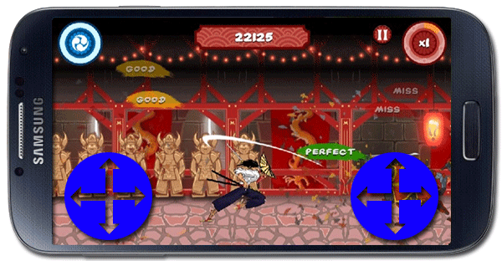

Figure 2: Blue indicates invisible touch screen controls. Visibility will be optional.

Overall this game will easily satisfy gamers of all ages and platforms. Initially the target platform will be windows/steam and mac. Android IOS and console versions of the game will be released after feedback is received from desktop users.

Concept art

<http://artemisdefenseinstitute.com/Blog/3261659>

<http://www.hardcoregamer.com/2012/10/03/playstation-mobile-now-available-on-vita/14775/>

history

<http://www.history.com/topics/samurai-and-bushido>